Canvastown School - Mussel Festival Campervan Site Booking Form – 2027

PLEASE SUBMIT 1 FORM PER SITE REQUIRED

PLEASE SEE INFORMATION BELOW

Parking space is available for certified self-contained campers at Canvastown School,(vehicle access via river access road beside school)

The Canvastown School Board of Trustees and the Ministry of Education WILL NOT ACCEPT responsibility or liability for any accident or injury happening to any person as a result of camping at the school grounds.

Courtesy van available throughout the day. (Koha appreciated)
For enquiries email:
office@canvastown.school.nz

BOOKING IN ADVANCE IS REQUIRED
There is a maximum capacity of 43 vehicles.
- Sites Available: From approx 4pm Friday through to 4pm Sunday
- Price: $20 per site per night
- Site sizes vary so it is essential you indicate the length of your camper or caravan/vehicle combo when booking.
Payment Info: Bank Account: Name: Canvastown School Board of Trustees: 12-3167-0233256-01

We will be in touch in the new year to confirm your site number.

SITE MAP ATTACHED (Please note the site map is subject to change)


Canvastown School 
5044 State Highway 6
ACCOMMODATION FOR SELF-CONTAINED
CAMPERS
Parking Space is available on the lower field at Canvastown School 5044 State Highway 6 Canvastown for certified self-contained campers
To Book Contact: office@canvastown.school.nz
Phone: Sandy 5742103 or 0275202225

BOOKING IN ADVANCE IS REQUIRED
There is a maximum capacity of 40 sites
♦ Available from 4pm Friday 13th March – 4pm Sunday 15th March
♦ PRICE: $20 per van/vehicle per night ♦ No Refunds
♦ Please indicate the length of your camper van /vehicle and caravan when booking.
♦ Canvastown School takes no responsibility for any damage incurred while on school
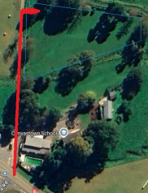
grounds.

PAYMENT
Payment to be made via internet banking and will secure your place if capacity is reached. If the event is cancelled no refunds will be given.
Bank Account: # 12-3167-0233256-01
Name: Canvastown School Board of Trustees Reference: *Please put your first and last names*
ACCESS: Follow the signage at Canvastown School
KOHA TO OUR KURA FOR 10MIN VAN RIDE TO FESTIVAL VENUE
5 MIN WALK TO PELORUS TAVERN TROUT BAR ,‘ THE SHOP’, AND HISTORICAL GOLD MINING MONUMENT.

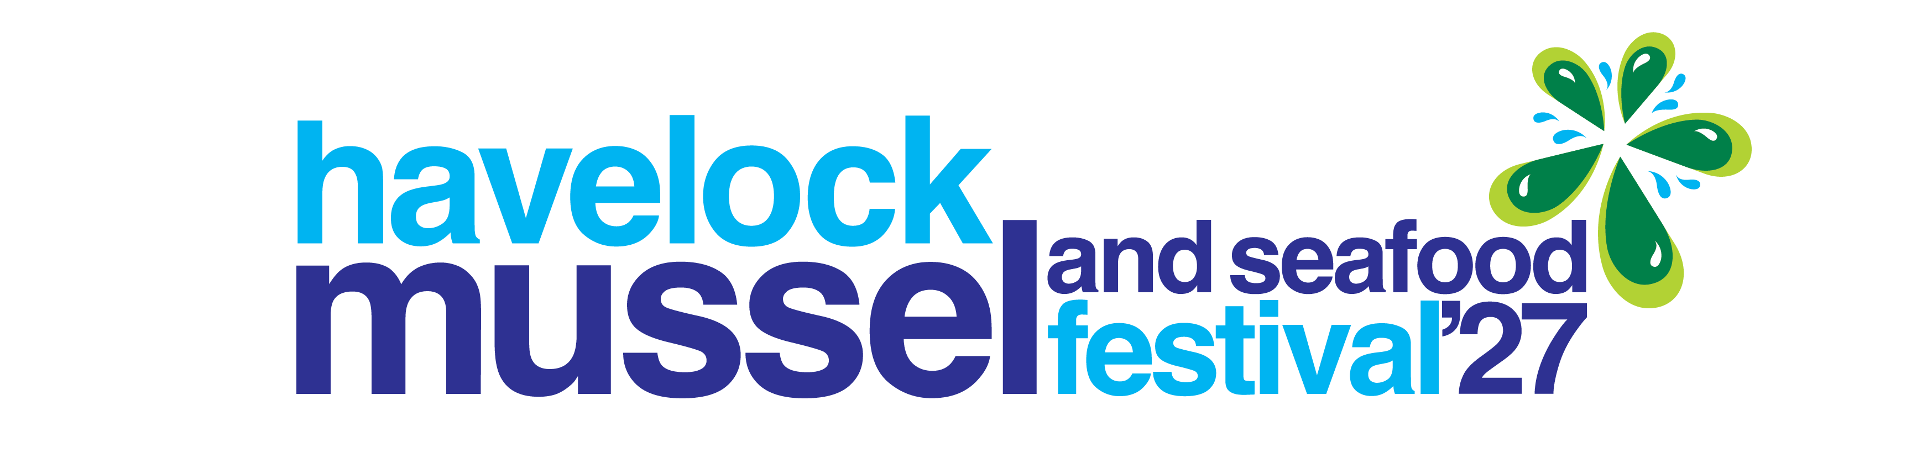

EMAIL:

NAME:

PHONE NUMBER:

WHAT IS THE LENGTH OF YOUR CAMPER/CARAVAN + COMBO?
__________________________________________________________________________________________
WHAT DAYS WILL YOU BE NEEDING YOUR SITE?

Friday 12th March

Saturday 13th March

Sunday 14th March

NOTES:

Please email booking slip to:
Office@canvastown.school.nz

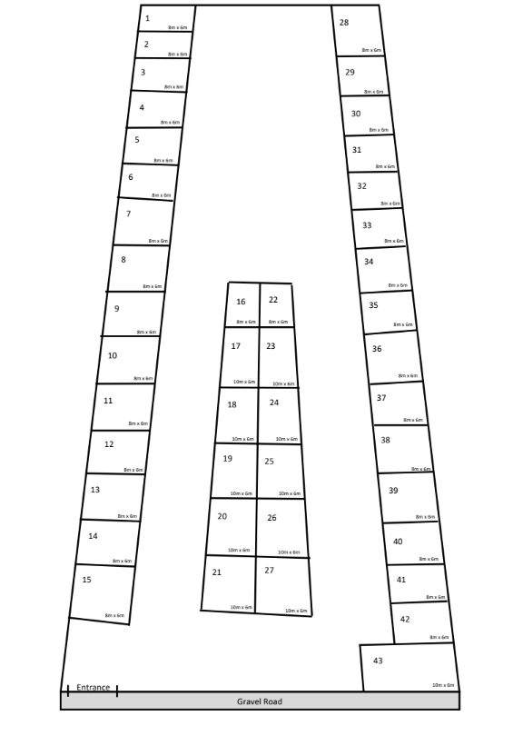

SITE MAP:

